Task 2 Points Breakdown

Task 2.1 Produce Power
- Connect a floating solar panel array to the grid
  - Retrieve the power connector – 5 points
  - Install the power connector into the hub
    - Remove the cover from the connection port – 5 points
    - Install the connector – 10 points
- Protect an offshore wind farm from corrosion
  - Replace a sacrificial anode onto the base of an offshore wind farm
    - Disconnect the old sacrificial anode from the base – 10 points
    - Connect the new sacrificial anode onto the base – 15 points
  - Mitigate corrosion
    - Conduct a visual inspection of the base structure – 5 points
    - Apply an underwater epoxy patch to the corroded area – 10 points

Task 2.2 Monitor Environmental Impact
- Collect life stages of jellyfish
  - Collect polyp stage jellies attached to the solar panel array
    - Collect 4 or more polyps – 10 points
    - Collect 1 to 3 polyps – 5 points
  - Collect a medusa stage jelly from mid-water
    - Visually determine medusa jelly is in open water – 5 points
    - Collect the medusa jelly – 15 points
- Collect fish species aggregated underneath the solar panel array
    - Collect 4 or more fish species – 10 points
    - Collect 1 to 3 fish species – 5 points
- Place a hydrophone in the designated location
  - Remove the hydrophone from the platform – 5 points
  - Place the hydrophone in the designated location – 10 points
  - Pull the pin to release the hydrophone from its base – 5 points

Total points = 120 points

Task 2.1 Produce Power
Objective: Connect a floating solar panel to the grid and protect an offshore wind turbine from corrosion.
- Retrieve the Power Connector
  - Objective: Remove power connector (1" PVC) from underwater platform.
  - Important:
    - Use ROV to take full control (not touching platform or bottom).
    - Connector is attached via a #6 hook and wire.
    - No part of it can touch the bottom/platform after retrieval.
- Remove Connection Port Cover
  - Objective: Remove 3" PVC cap from 2" PVC port.
  - Important:
    - Can be done before or after retrieving the connector.
    - Must be fully under ROV control and no longer touching ports.
    - Treated as debris → must either stay with ROV or be returned to the surface.
- Install the Power Connector
  - Objective: Insert Velcro-covered connector into Velcro-lined port.
  - Important:
    - Velcro hooks are on the connector; Velcro loops are inside the port.
      - You need a tight, aligned fit to ensure Velcro engagement.
    - Must be:
      - Not touching ROV.
      - Fully inserted.
      - Velcro-to-Velcro secure stick.
    - Must remain installed the entire run or you lose points.
    - You can reinstall if it becomes dislodged.
- Replace Sacrificial Anode
  - Objective: Swap old silver-painted PVC anode with a new one.
  - Important:
    - Both anodes are painted silver, so color won’t help distinguish.
    - Removal:
      - Rotate until PVC rods align with slot, then remove.
        - The disconnect method is mechanical: Turn/rotate the old anode until its ½-inch rods align with a slot in the corrugated plastic.
      - Must be under ROV control and not touch base afterward.
      - Considered debris – return to surface or keep with ROV.
    - Installation:
      - Insert both ½" PVC sections into slot below plastic sheeting.
        - On insertion of the new anode: The PVC rods must go fully through the slot, and be below the sheeting.
      - Must remain in place for full run or lose points.
      - You can reinstall if it falls out.
    - Importance of alignment and full insertion:
      - Failure to align the rods properly may result in the anode falling out, costing you points.
- Mitigate Corrosion by Applying Epoxy Patch
  - Objective: Find and patch corrosion on one “leg” of wind base.
  - Important:
    - Inspection:
      - Find orange paint (≥1.5 cm wide) on one leg (not underside).
      - Show corrosion on video feed to judge.
        - This must happen before applying the patch.
    - Patch:
      - The patch is a cloth towel with Velcro loops on each end.
      - Dish towel with Velcro loops must:
        - Attach above and below spot.
          - The “legs” have Velcro hooks, and both ends of the towel must attach.
        - Fully cover the corrosion.
      - Must stay on for the entire run.

Task 2.2 Monitor Environmental Impact
- Collect Polyp-Stage Jellies
  - Objective: Remove black chenille polyps from holes in solar array PVC and return to surface.
  - Important:
    - Polyps are:
      - Made from black chenille pipe cleaners
      - Inserted into 3/16-inch holes in the solar array’s PVC frame
      - Small and likely delicate: Ensure your manipulator doesn’t bend or break them during extraction.
    - Must be under ROV control and fully removed from panel.
    - Must be placed at surface, side of the pool.
- Collect Medusa-Stage Jelly
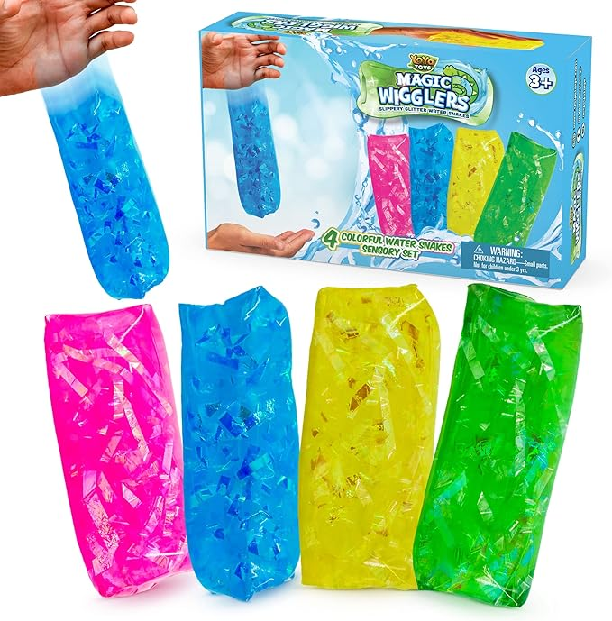
  - Objective: Release jelly (water wiggler), observe it float, then collect it.
  - Important:
    - Pull pin to release from 3" PVC holder.
      - Enclosed in a 3-inch pipe holder at the start.
      - Must pull a ½-inch pin to release the jelly.
    - Must visually confirm jelly is floating (not touching holder/framework).
    - Show floating state to judge on video.
      - DO NOT COLLECT UNTIL THIS STEP IS DONE!
    - No direct pressure on jelly body during collection.
      - Collect surrounding water with jelly.
    - Return entire collection mechanism (with jelly inside) to surface.
      - You can surface the ROV with the jelly inside or detach the container and send that up.
    - Never remove jelly from container during run.
- Collect Fish Species
  - Objective: Remove ping pong balls from PVC frame under solar array.
  - Important:
    - Fish are floating within a square of ½-inch PVC.
    - You need to remove and bring them to the surface, side of the pool.
      - Suggest using either a scoop net, cage, or suction system.
    - Ensure you don't just dislodge them:
      - Must be under ROV control and returned to surface.
    - Ensure complete removal from the floating structure.
- Place Hydrophone
  - Objective: Move hydrophone from platform to yellow square and release sensor.
  - Important:
    - The hydrophone:
      - Starts on a platform on the bottom
      - Made from ½-inch, 2-inch, and 3-inch PVC
    - Remove from platform:
      - No longer touching platform or pool bottom.
    - Place into yellow square:
      - Must be upright and completely within yellow 50x50 cm square.
      - No part of base can touch or be over PVC edges.
      - Must remain upright and in bounds throughout the run.
      - Can reposition if it gets knocked/moved.
    - Release:
      - Pull pin so 2" sensor floats above 3" base attached by rope.
      - Show sensor floating to judge on video.
      - Even if hydrophone was knocked over earlier, you can still get these 5 points.

Critical Guidelines to Avoid Losing Points
- Debris: Port cover and old anode must be with ROV or returned to surface at end.
- Permanent Placement:
  - Power connector, anode, patch, and hydrophone must stay in place/upright until end.
  - Points are lost if items are dislodged.
- Video Verification:
  - Corrosion ID and medusa jelly must be shown to station judge via ROV camera.
- Medusa Handling:
  - Do not squeeze, press, or directly grab jelly body.
- Accuracy on Hydrophone:
  - Must be upright and fully inside the yellow square. Can be repositioned if needed.

General Operational Insights
- During the 5-minute setup period, some task components like:
  - The new sacrificial anode
  - The epoxy patch
  - And potentially collection containers
will be located at the surface, side of the pool.
    - You must collect and transport them using your ROV at the beginning of the mission.
- All debris such as:
  - The port cover
  - The old anode
must either be returned to the surface or be under control of the ROV at the end of the run.
    - Loose debris left at the bottom will likely result in a point deduction.
- If a task item becomes dislodged (e.g., power connector, patch, anode, hydrophone), you can attempt to reinstall it to regain the lost points.

